Photoshop Concepts D
Fonts and Typography

This unit will utilize the Type tool and how to work with Type, including modifying character and paragraph styles, adding Layer Styles, and modifying Type to create custom looks.

Understanding Fonts—Anatomy of Type
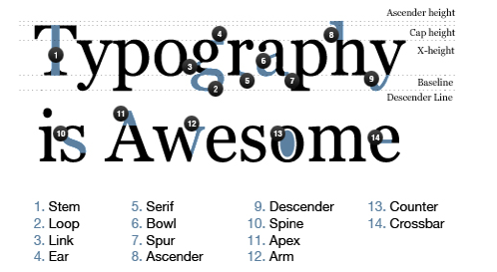

Types of Fonts
Terms

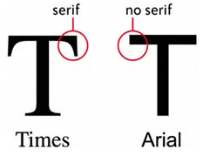
- Serif: Serif typefaces are called “serifs” in reference to the small lines that are attached to the main strokes of characters within the face. Serif typefaces are most often used for body copy in print documents, as well as for both body text and headlines online.
- Sans Serif: Sans-serif typefaces are called such because they lack serif (without serifs) details on characters. Sans-serif typefaces are often more modern in appearance than serifs.
- Script: Scripts are based upon handwriting, and offer very fluid letterforms. There are two basic classifications: formal and casual.
- Display/Decorative: Display typefaces are probably the broadest category and include the most variation. The main characteristic is that they’re unsuitable for body copy and are best reserved for headlines or other short copy that needs attention drawn to it.
- Grunge: A subset of Display, but most known for its eroded or broken appearance.
- Dingbat: Dingbats are specialty typefaces that consist of symbols and ornaments instead of letters. Wingdings is probably the best-known dingbat font, though there are now thousands, often created around themes.

Installing Fonts (Windows 8)
Download the font (usually it will be a zip) 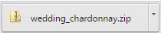
Lots of Great Free Sites for Fonts!
http://www.dafont.com
http://www.urbanfonts.com/
http://www.1001freefonts.com/
Double-click to open the ZIP file and it will open. Review the list and identify which is the font file (typically TTF/True Type Font). Double click-that file to Extract it.
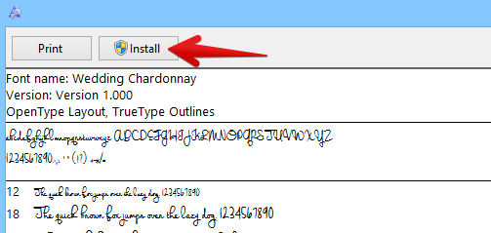
A preview of the font set appears. Click Install. You can only install on computers where you have rights. In my classroom, you should have rights, but probably not anywhere else on campus. At home, you should be able to do this as well. Remember a font ONLY WORKS on the computer where it is installed. If you move to another computer, you need to install it again on that computer to use it.
Typically, you have to restart the application (and sometimes the computer) for the font to show up on your fonts list. And, some fonts just don’t work.
Practice A
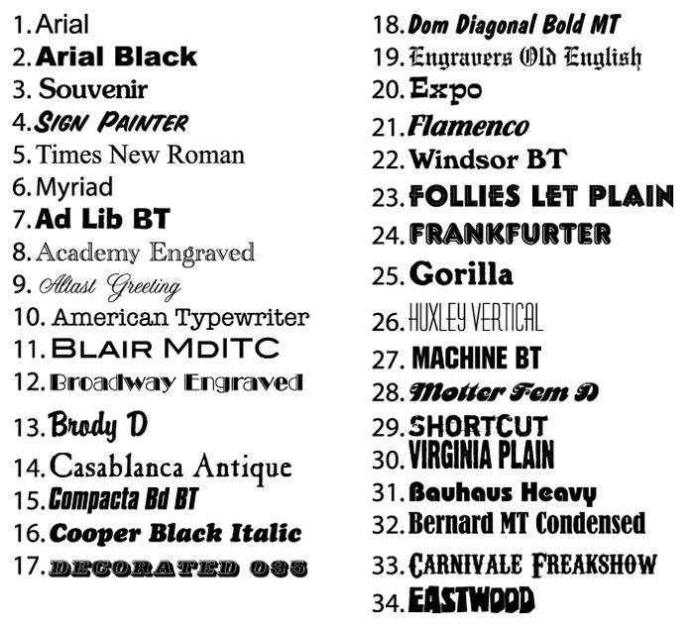

Type Tool in Photoshop
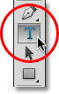
You can insert Horizontal (the normal kind) or Vertical (click and hold; goes up/down). Just click with the Type tool to create text. This creates “point” type. The difference between point type (also known as character type) and area type (also known as paragraph type) is that with point type, Photoshop simply adds the text at the spot, or "point", where we clicked in the document with the Type Tool. This is by far the most common way of adding text to a document because in most cases, we're just adding small amounts of text on a single line, which is what point type is best suited for.
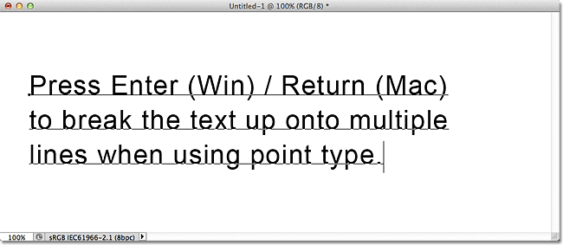
With point type, we simply click with the Type Tool, then start typing. Unless we add a manual line break to our text when using point type, all of our text will be added to a single line and will even run right off the edge of the document if we keep on typing. You can right click to switch between point/paragraph type if you chose the wrong one).
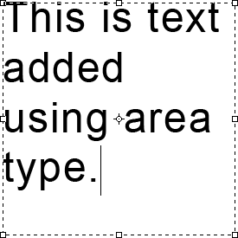
If all words don’t fit, you will see an overflow symbol. Click and drag that to resize the box.
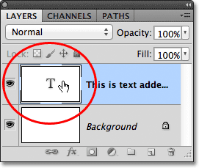 NOTE: To select all the text on a layer, just double click the thumbnail.
Change the font, size, color, alignment and apply other features (such as warp) using the Options bar.
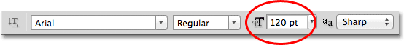

Character Panel
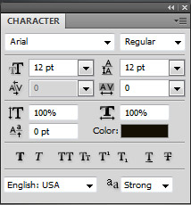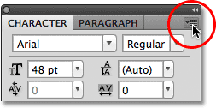
- Leading: Spacing between lines
- Modify kerning (spacing between two letters) or tracking (spacing between all letters in a block of text) of letters
- Modify scale of letters (stretch/smash horizontally or vertically)
- Baseline Shift: Modify baseline/position of letters (like exponents or subscripts)
- Other buttons for faux bold or italic, uppercase, small caps, super/subscript, underline, and strikethrough
- TO RESET BACK TO DEFAULTS click the top right little drop down arrow and choose Reset Character.

Paragraph Panel
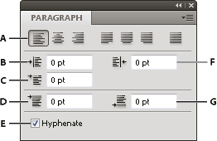
- Alignment and justification
- Left indent
- First line left indent
- Space before paragraph
- Hyphenation
- Right indent
- Space after paragraph

Warping Type
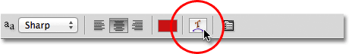
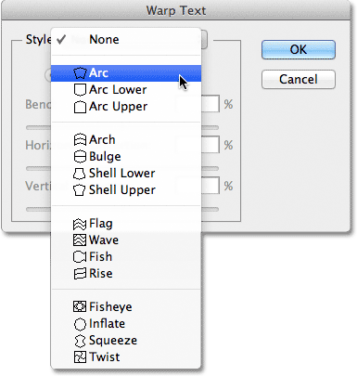

Type in a Shape
Access the Custom Shapes tool (hides under rectangle tool) 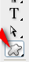
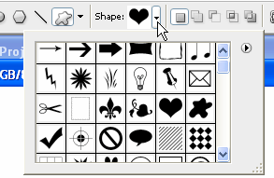
Choose a Custom Shape from the drop down list (can access categories if you press the “play” button or “load” shapes that you download (CSH files)
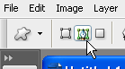
Set options to Paths so instead of drawing the shape, it will actually just draw the outline (which does not print) of the shape.
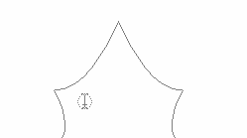
Then, click and drag and draw the path. Paths do not have a fill and will disappear when you click off the layer. 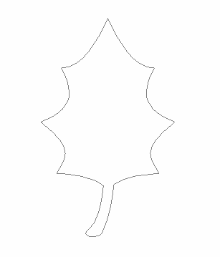
Point inside the selection with the Type tool. Your cursor will have “parenthesis” around them.
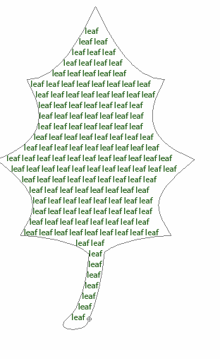
Type the words in there (I like to type one word or phrase a few times with a spacebar after it and then copy/paste over and over to fill it in (Control+V is paste).
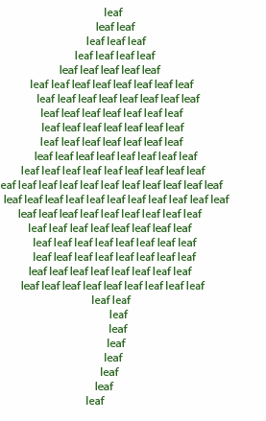Once you click off the layer, you will notice the “path” (border) disappears. That’s all there is to it! Easy peasy! Of course, you can always click in there and change the color of parts of the text to add depth and interest. Good times!

FUN FACT:
You can right click a Type layer and convert it to a Shape. Then, the letters are not editable like Type, but you can use them as shapes (helpful with Dingbat fonts). And, you can reshape it using the Pen tool or white arrow.

Type on a Path
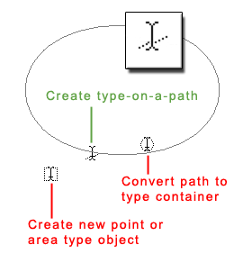
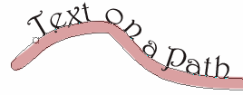
Note the cursors at right. Notice what the type on a path cursor looks like!
First, create a path. You can do this many ways. Options include: (NOTE: Pen tool is the best way and simplest way if you can get comfy with the Pen!)
Draw Your Own--
- Draw it. Make a new layer and use the pencil tool or paintbrush and draw a path freehand. Then, point to the thumbnail icon of the layer in the Layers Palette. Hold Control and click that icon and you should notice that your drawing is selected (has marching ants around it).
- Then, access the Paths palette (it’s docked by the Layers palette). Then click the Make Path from selection button at the bottom. It will make a path so you can type on it.
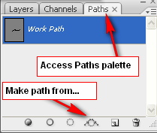
- Switch back to the Layers palette and click the Type tool.
- Point to the path and get the “Create type on a path” cursor (look above!). Then, click and start typing.
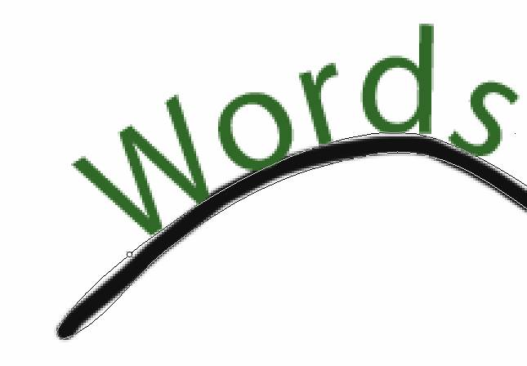 To alter the starting point of the words, hold Control and click before the words and drag the black little fat arrow around.
- To put the words under the path, just highlight and use the Baseline Shift option in the Character palette.
- Now, you can delete the layer that has the path drawn on it (or just turn visibility off). You don’t want that to show.

Use a Shape—
- Access the Custom Shapes tool (hides under rectangle tool)
- Choose a Custom Shape from the drop down list (can load more)
- Set options to Paths so instead of drawing the shape, it will actually just draw the outline (which does not print) of the shape.
- Then, click and drag and draw the path
- With the Type tool, point to the edge of the path and look for the cursor with the slanty line-- 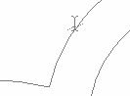
- Click and type!
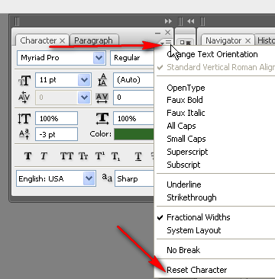
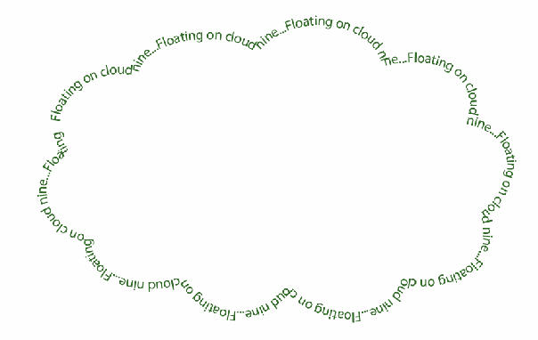
- Adjust as needed by holding Shift and dragging the black arrow or adjusting baseline shift. NOTE: If you are having unexpected results, trying resetting the Character palette first.

Pen Tool Cheat Sheet
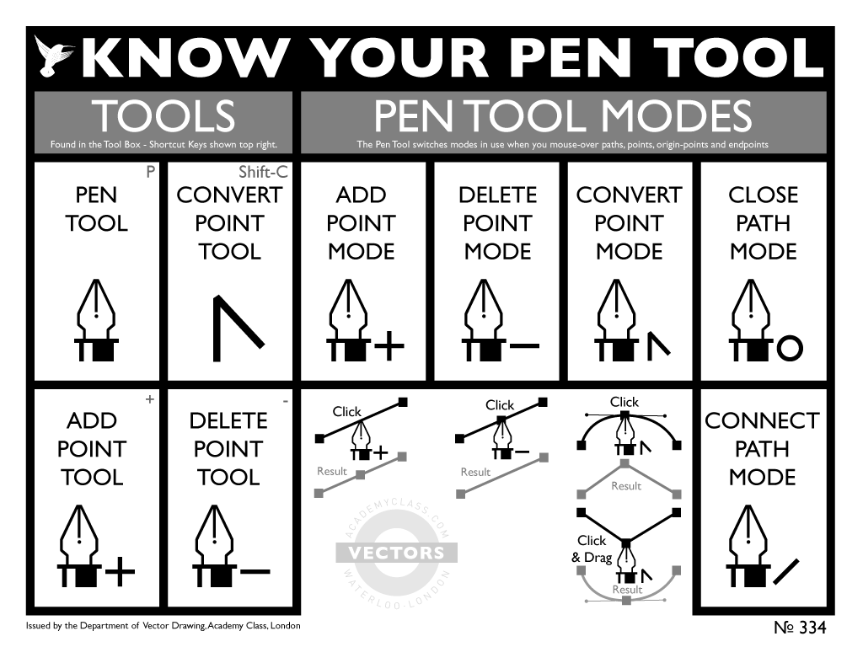
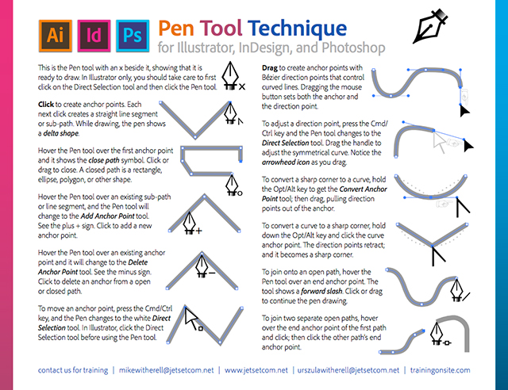

Text on a Swirl
You can place text on a swirl if you can create a swirly path. The easiest way to do that is as follows:
- Draw a circle with a solid fill. Rasterize the shape layer. (Right click the layer—Rasterize) 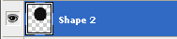
- Click the Filter Menu> Distort> Twirl and set however you want ( I go all the way up). Press OK.
- It’s swirly, but not crazy swirly. To make more swirly, repeat by pressing Control+F. Better!
- Use the Magic Wand to select the swirl. Then, right click the swirl and press Make Work Path.
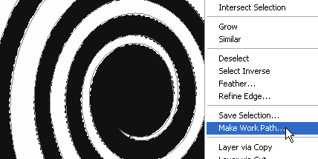
- With the Type tool, click on the edge of the end of the path and get the Create Type on a Path cursor. Make adjustments in the Character palette and start typing. For this type of effect, I like to type, copy, paste a few times, and then size some down and repeat the process so it appears to get smaller:
- Finish off by making final adjustments and then hiding or deleting the swirly layer. Tada!
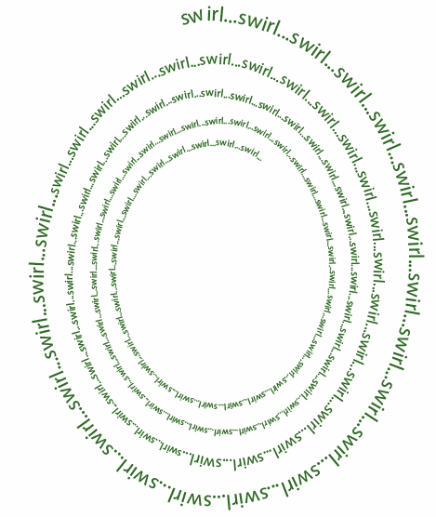

Clipping Mask with Type

- Make a text box. Type a lot of whatever in it. NOTE: It doesn’t usually look too good with hyphens, so fix that by unchecking they Hyphenate box in the Paragraph palette.
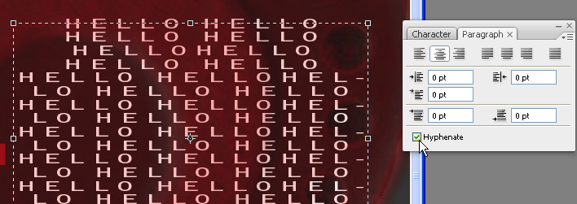
- Create the big letter (or make a layer for a brush stroke, draw a shape, etc.). Put it behind the text that you want to fill into the shape.
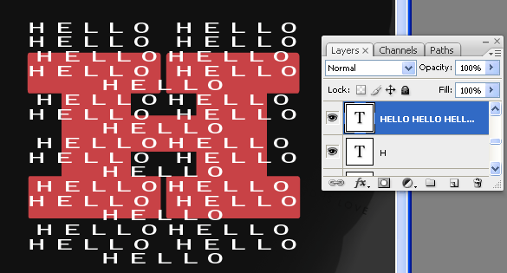
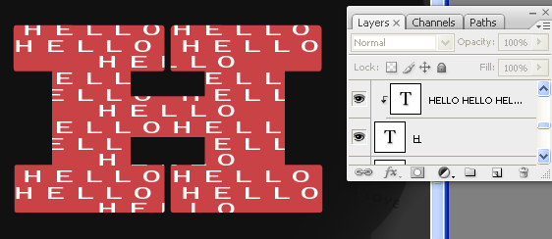
- Hold down ALT and click between the layers to “clip” it:
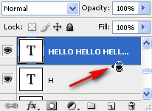
- All done!

Gradient Text
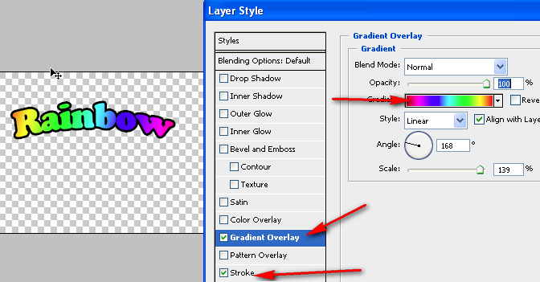
- Create text. Warp if desired.
Add a Gradient Overlay Layer Style
- Adjust gradient to your liking.
- Optional: Add stroke to define letter borders.

Bloody Text
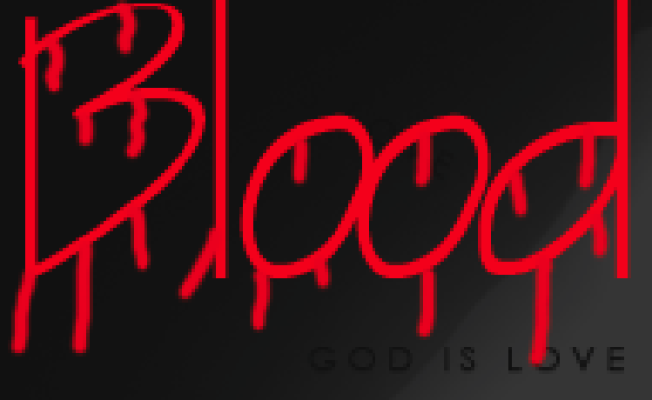
First, create some text.
- Next, rasterize the Type layer (right click layer). This turns it into “paint” instead of Type.
- Using a paintbrush, draw some blood oozing from the letters.
- Use the Liquify filter and click on the very ends of the drips with the Bloat tool. Don’t click much and don’t drag (unless you prefer to).
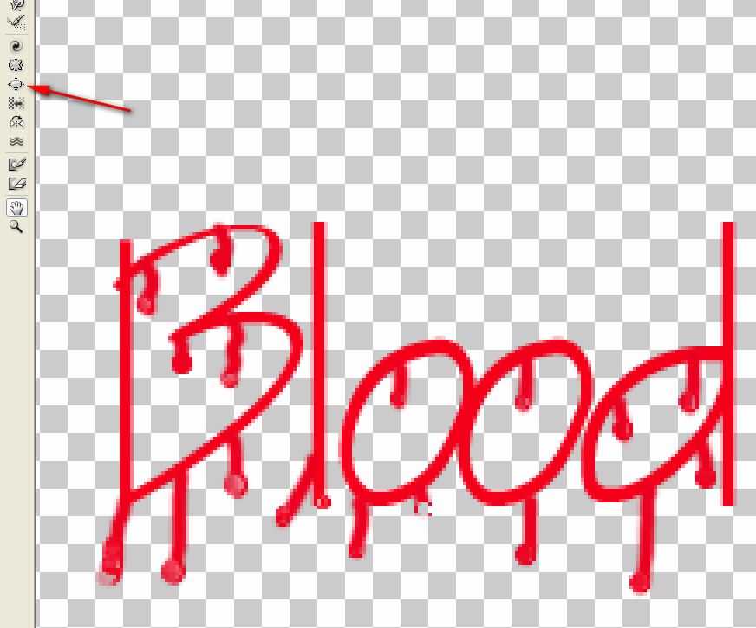
- Add a Bevel/Emboss Layer Style to give it a 3D type of look:
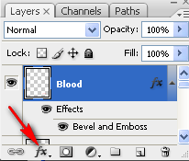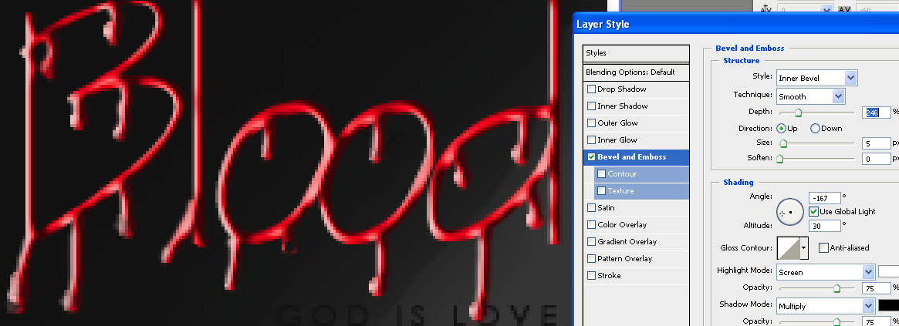
- All done!

