Photoshop Concepts B
Making Selections
To remove a selection (make the “marching ants” go away), click Control+D; if you accidentally deselect, just Select>Reselect.
There are various ways to select parts of images in Photoshop. Below will detail various tools and their application.

Magic Wand
This is probably the easiest tool to use, but it can only really be used with a solid background.
- Click the Magic Wand tool.
- Adjust the Tolerance on the Options bar. A low number means it will be really picky (good if you have an object close in color to the background). A high number means it will not be picky (it will automatically select more, even shades of the color you click).
- Click on the background (solid area) of the image with the wand. If there is an additional part that needs to be included (like on the donut in the middle), you will need to hold Shift and click again to add that area.
- That selects the background, but you only want the object to drag over to a new image (if you drag over now, you will drag the background and not the object!). So, right click the selection and Select Inverse.
- Now, you can switch to the Move tool (V) and drag it over.
  - NOTE: You can also click the Refine Edge tool on the Options bar to preview the selection before you switch to the tool and move it over.

Refine Edge
A useful tool that can be used in conjunction with any selection (AS LONG AS a Selection tool is currently clicked on) is the Refine Edge tool on the Options bar.
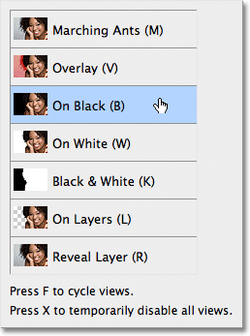
When you press this, a nice little box appears. This allows you to “refine” your selection. It’s incredibly helpful with difficult selections, like hair or fur.
You can preview the selection in various ways. Probably most useful is on black or on white:
Once you see the preview, now you can start moving sliders to tweak the selection. Directly below the View Mode option in the Refine Edge dialog box is a section called Edge Detection. This, as they say, is where the magic happens. To add more of the hair to your selection, click on the Radius slider and begin dragging it towards the right: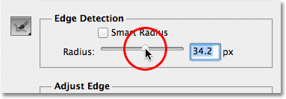
After that, you can use the Refine Radius brush to add in more detail. If you get too much, just switch to the Erase Refinements mode. You can always cancel and start over, too.
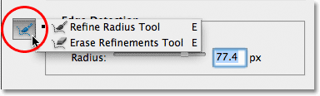
We can remove the fringing using the Decontaminate Colors option, found in the Output section at the bottom of the dialog box. By default, Decontaminate Colors is turned off.
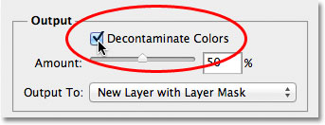
Now clean up the fringing by dragging the Amount slider towards the right. The default Amount value is 50%. As you drag the slider further to the right, Photoshop removes the fringing by physically changing the color of the pixels around the hair so that they match the color of the hair itself rather than the original background color.
Finally, choose how to output it. If you just want to move it out as marching ants, then choose Selection. If you want it to move it to whole layer by itself, you can choose New Layer.

Marquee
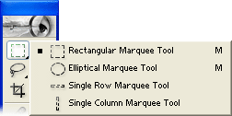

The Rectangular and Elliptical Marquee tools allow you to select circular or rectangular areas.
NOTE: Though the Options bar has a Feather option, don’t use it; you can always just click Refine Edge and add a feather afterward.
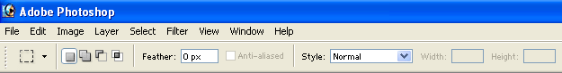
To draw a perfect circle or square, just hold Shift while drawing.

Color Range
This isn’t a “selection tool” but it is another way to select something and sometimes works very well. The Color Range selection option will pick an object similar to the Magic Wand, but with more control.
Go to Select > Color Range, then use the color picker to click on the object. Adjust the fuzziness if needed.
What’s really nice is that you can “invert” the selection with a check box rather than a second step. Then, press OK.
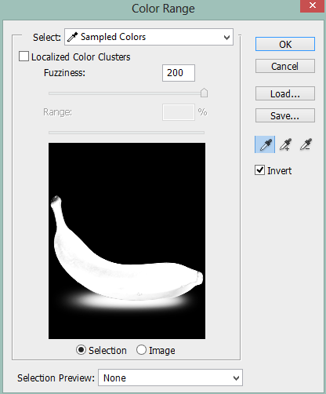 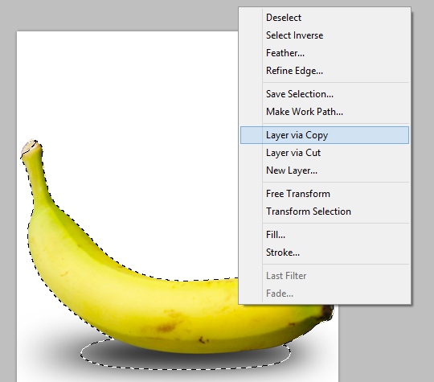
Once you have the selection, simply right-click it and create a New Layer via Copy from the selected object.

Lassos
There are three types of lassos, each with various purposes. 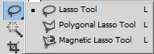
Lasso: The regular lasso tool is a free hand drawing selection tool. Click and hold the mouse, drag around what you want to select, and let go. It’s honestly the least useful tool unless you have a crazy steady hand. But, occasionally, if you are zoomed in really close trying to add in little pieces, it can be handy.
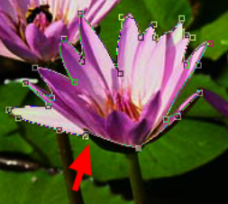
Polygonal Lasso: The polygonal lasso tool allows you to click points around your picture to create your selection. Click on a point, let go, and move to your next point and click again. A straight line is drawn from point to point, like a “connect the dots” page. If you mess up, just press Backspace to scoot back.
Magnetic Lasso: The magnetic lasso tool allows you to select an object by tracing its outline. Click on the object’s edge to create a starting point. Then, trace around the edges of the image. It does not have to be perfect as the tool magnetically sticks to the edges of the image. Make sure to click the mouse when it changes directions or in corners. To finish the selection, you have to click back on the starting point. It will have a small circle next to it when you are back to the beginning. If you mess up, just press Backspace to scoot back and move your mouse back to that point.
You can mix and match selection tools and add/subtract from selection using the buttons on the Options bar.

Quick Selection
This tool is like the "Magic Wand" except when dealing with objects that contain many colors and tones, the Quick Selection Tool helps to grab all of those colors. As you brush overtop of the object, Photoshop will continuously sample the surrounding area, and do its best to create a seamless selection.
The Quick Selection Tool works by allowing you to paint a selection, with the selection snapping to details as you select. Be sure to modify the brush size as needed by using brackets— [ to decrease the size and ] to increase the size of the brush. Zoom in closely for best results and hold Spacebar to switch to the Hand tool as needed to move around the zoomed in image.
- Select the Quick Selection tool from the Tools panel. The tool looks like a wand with a marquee around the end. It shares the Magic Wand tool’s flyout menu. You can also press the W key, and then press Shift+W until you get the tool.
- If you’re making a new selection, be sure that the selection option is set to New Selection or Add to Selection on the Options bar.
- Select your desired brush settings from the Brush picker on the Options bar (size and hardness).
- Select the Auto-Enhance option to have Photoshop assist you by automatically refining your selection by implementing an algorithm.
- Click and drag over the desired areas of your image. Your selection grows while you drag. If you stop dragging and click in another portion of your image, your selection includes that clicked area.
- Change your selection as needed. You have three options to change your selection:
  - To add to your selection, hold down the Shift key while dragging across your desired image areas. (If the Add to Selection option is selected on the Options bar, you don’t have to hold down the Shift key.)
  - To delete from your selection, press the Alt key while dragging across your unwanted image areas.
  - You can also select the Add to Selection and Subtract from Selection options on the Options bar.|
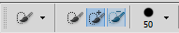
- If you need to further fine-tune your selection, click the Refine Edge option on the Options bar. It’s always a good idea to at least preview your selection.
BONUS INFORMATION!!!
Some more handy dandy things you need to know, not necessarily about “selecting” in Photoshop…

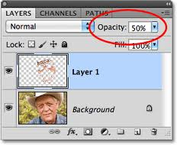
- A “checkboard” pattern represents transparency on a layer.
- If a layer is locked (like the background layer) and you want it unlocked, simply double-click the layer and press OK. This turns it into a Layer 0.
- To make something “see-through” or partially transparent, you can modify that layer’s Opacity. This is on the Layers Panel in the top right (a percentage). 0 means invisible (that’s bad) and 100 means you can “totally see it.”

