Photoshop Concepts A
Adjustments, Transformations, Styles, Brushes, Shapes, Clipping Masks and Fills
NOTE: You can combine Photoshop images together using the Move tool (press V to access). Put the images side by side (or Window> Arrange> pick one) and then Move the image from one picture to the other. In a future lesson, we’ll show you to select only specific parts of images to move. Once you start compositing (combining) images, you may wish to dress up your document with styles, brush stamps, or shapes. Or, you might need to adjust something to get the color or lighting to match. That’s what this unit is all about!

A few types of Adjustments
Using the Image menu, you can make many adjustments to a photo. Adjustments on the Image menu are not reversible; they are what we call destructive. That essentially means that if you come in the next day and want to get rid of the adjustment, you can’t. Too bad.
If you are using multiple photos or might want to make changes later, it is better to use the Layer menu and create Layer adjustments (New Adjustment Layer; and then checkmark the box for creating a clipping mask to attach it to the current photo/layer):
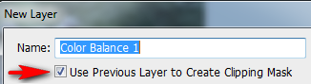
Brightness/Contrast
Levels: Adjusts color balance by setting the pixel distribution for individual color channels. This appears like a mountain; the black slider controls dark areas and the white slider controls light areas. If a picture doesn’t appear true white, this is a good adjustment to make.
Black and White: This turns a photo to monochrome. On the dialog box, the sliders adjust how bright or dark each color will appear in the black and white version, and we can use them to emphasize or de-emphasize certain objects or areas in the image, brightening areas we want to bring attention to and darkening less important areas, based entirely on the original color of those areas. Dragging a slider towards the right will brighten areas that contained that color, while dragging a slider to the left will darken areas that contained the color. You can go a step further and tint an image by checking the box at the bottom and modifying the hue/saturation.
HDR Toning: You can create HDR-style effects using Photoshop and just one photo. This one is pretty neat in that you can do some “Instagram-ish” stuff with it. HDR stands for High Dynamic Range. In Photoshop, you can adjust the custom settings or you can pick a preset at the top.
Hue/Saturation: Very helpful one. Technically, this adjusts the hue, saturation, and lightness values of the entire image or of individual color components. Hue changes the color and saturation modifies the intensity of the color.
Photo Filter: Makes color adjustments by simulating the effects of using special camera filters. Pictures that are “too blue” need a warming filter and pictures that are “too orange” need a cooling filter applied.
NOTE: To Undo a mistake, press Control+Alt+Z or Edit>Step Backward if you want to undo more than once. Or, use the History panel (Window> History). Better to undo than try to fix!
Selective Color: Adjusts the amount of process colors in individual color components. For instance, you can “liven up” all the red areas at one time in an image.

Layers Panel—Layer Styles (fX)
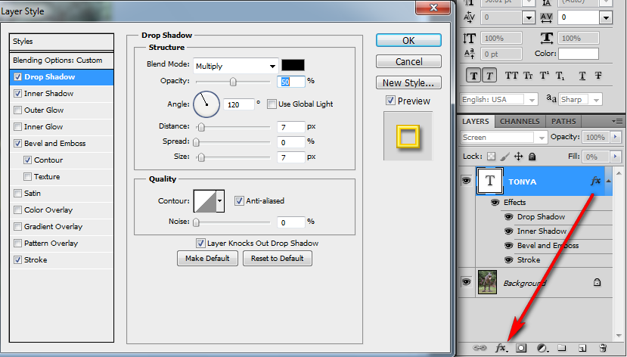
Styles include: Drop shadow, inner shadow, outer/inner glow, bevel and emboss, stain, color overlay, gradient overlay, pattern overlay, and stroke (border).
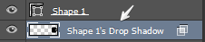
BONUS INFO: This feature is used to create drop shadows. However, often people want to create “real” shadows (like cast shadows). You can separate a style from the Effects by right clicking the style name (Drop Shadow) and going to Create Layer. Then, that will be on its own layer and can be moved around and transformed (see #4) separately.

Styles Panel
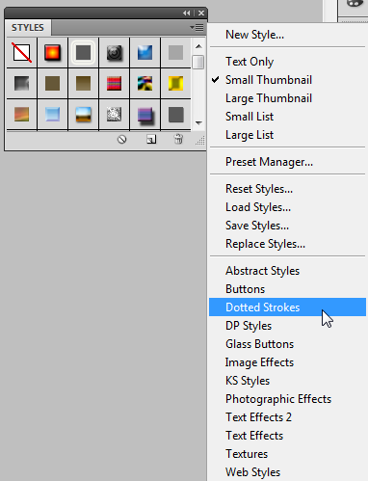
The Styles panel contains preset styles that you can then customize in the Layers panel. If your Styles panel is not visible, check under Windows> Styles.

You can also download ASL files and click “Load Styles” to load them up and use them.

Transform
You can press Control+T to activate transform and then right-click the mouse for options.
Or, you can go to Edit> Transform and choose options from there. Notice that some options will be grayed out if you are using Type or Shapes.
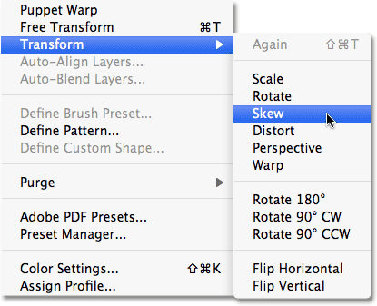
REMEMBER: Always hold Shift when resizing an image and drag from a corner to ensure you don’t smash the image!
You can add Type 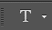 (words) and transform it. Type has its own special Warp Transform on the Options bar . Just click to create a text box, modify the font on the Options bar at the top, and then apply Warp using that button. Press check to accept/finish.
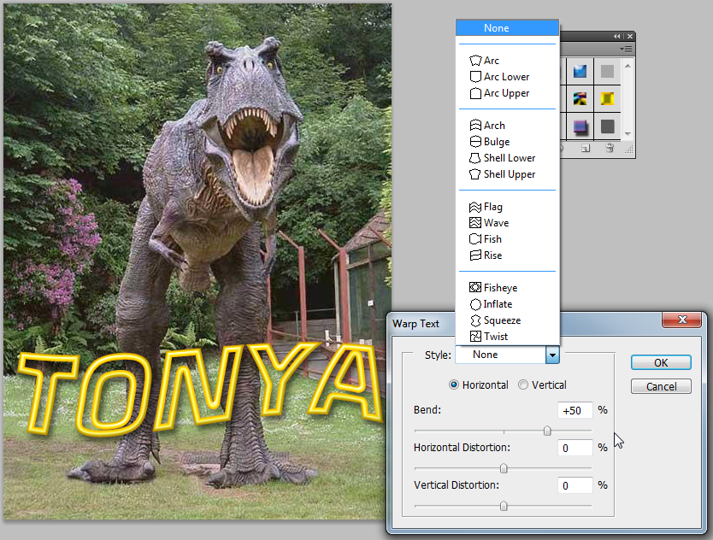
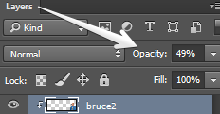
NOTE: You can make layers “see through” which is often common for things like cast shadows. Just use the transform options and press check. Then, modify the Opacity on the Layers panel. Just remember that 0 is invisible.

Brushes
First, many tools are “like Brushes” in Photoshop (the Eraser, for example). But, the Brush tool is used to draw.
You can press B to toggle to the Brush tool. You should always create a New Layer on the Layers panel before adding anything new with a Brush. If you want to be able to style it or transform it, it needs to be alone on that layer. When you use a brush, you set the size by using the [ and ] button (near the P on the keyboard). NOTE: If you press Caps Lock, the Brush will appear as a “precise cursor” (plus sign) instead of a previous of the Brush size/shape.
On the Properties bar, Brushes have specific options:
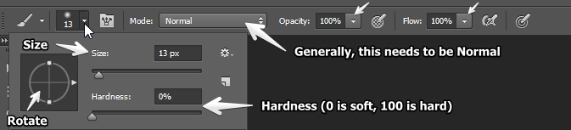
The color is not up there. You have to use the box at the bottom of the Tools panel to change color:
The top color (foreground) is the Brush color.
Hard vs. Soft Brush
The Hardness of a brush directly pertains to how crisp the edges are. The more you increase the Hardness percentage, the cleaner the brush stroke. For a more diffused edge, simply decrease the Hardness.
Opacity
Opacity also plays an important role in defining the Hard or Soft nature of a Standard Round Brush. The higher the Opacity, the more paint you're applying.

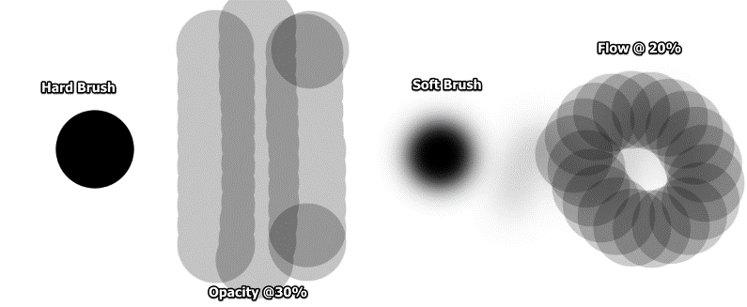

You can also load special brushes. There are some brush sets (categories) built in. Push the button in the top right corner to access more
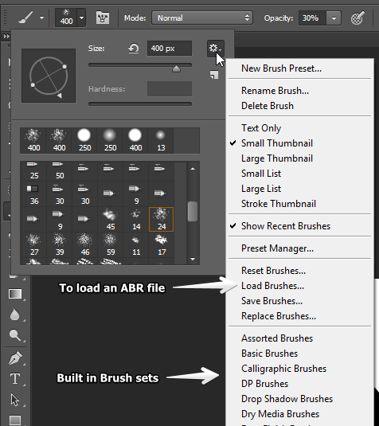
Places for free Photoshop Brushes (ABR files can be loaded; many download as ZIP and must be extracted first):
- http://www.brusheezy.com
- http://myphotoshopbrushes.com
- http://qbrushes.net/

Eraser
The Eraser works like a brush (has shapes to it) but it erases. Any Brush can be used as an Eraser. Erasing is destructive, so once you do it, it’s done (so I avoid using it). There are better ways (which we will learn later) for removing backgrounds. However, if you draw something with a Brush and need to get rid of it and it’s on its own layer, this is the tool for you.
There are two other tools hiding under the Eraser—Background Eraser and Magic Eraser. Either of these are also possibilities (though not the ideal tool) for removing backgrounds from images (works okay on solid backgrounds or to remove a sky, for example).

Shapes
The Shape tools allow you to add graphic shapes in the form of a filled layer with a vector mask, a solid fill, or as a path outline. Using the Shape tools you can draw rectangular, rounded rectangular, elliptical, polygon, line or custom shapes.
The Shape tool modes include a Shape mode that will create filled shape layers. Alternatively, there is a Paths mode available from this menu which can be used to create a pen path based on the shape tool settings (something for much later on).
Click and hold the Rectangle shape tool to get more shapes. The Custom Shape tool (looks like a Blob) provides access to lots of cool shapes and shape categories. Or, you can load others (CSH files) that you can download.
Shapes do create differently depending on the version of Photoshop. The older versions (CS5 and CS6) maintain the color of the shape along with the vector mask on the layer (and you double click it to change it). In newer versions, the fill and stroke are dictated based on the Properties bar.
Places for free Photoshop Shapes (CSH files can be loaded; many download as ZIP and must be extracted first):
- http://photoshop.cc/custom-shapes
- http://www.brusheezy.com/shapes
- http://dezignus.com/category/shapes/

Clipping Mask
Now that you know how to add shapes, here’s a fun trick. You can “clip” pictures into shapes!
The only real rule here is that you need to put the picture on the layer immediately above the shape. Then, right click the picture and choose Create Clipping Mask. It will clip into the shape and an arrow will point down (you can also do this by just clicking between the layers while holding Alt).
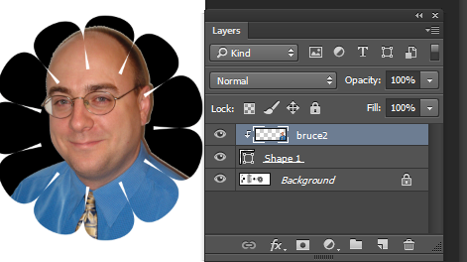

Fills—Solid, Gradient, and Pattern
Gradients
You need a blank layer to create a fill, whether it be solid or gradient. When you drag with the Gradient tool inside an image window, a gradient fill is created between those two points.
Gradient Properties: Note that you click the Gradient ramp to customize the colors.
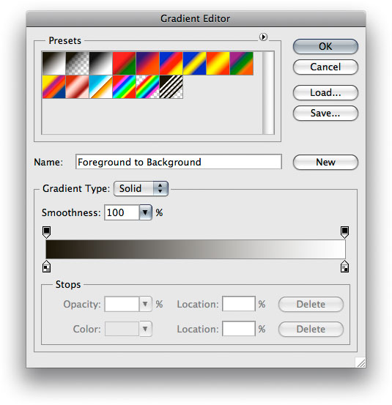 Gradients have “stops” that indicate the colors at the bottom and you can add more by clicking or remove them by just dragging the stops down.
Solid Fill
The Paint Bucket for fill hides under the Gradient tool (click and hold the tool). Simply have a blank layer ready, pick a color on the Color Picker, and click once to fill with color.
If you want to fill with a pattern instead, simply press the drop down menu on the Properties bar.
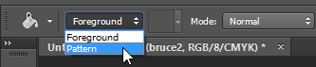 Then, choose a Pattern.

Color Mode
One major issue sometimes when compositing pictures into one piece of work is that some images won’t play nicely. For example, you might try to drag over and it won’t do it. When combining pictures, both must have the same Color Mode. GIF images, for example, have Index color mode. JPG have RGB color mode. So, if you have an image where the Background layer doesn’t say that (says Index, for example), just change the mode under Image> Mode.
