FOOD FOR THOUGHTREAD THIS BEFORE YOU BEGIN!!!
Today, you will NOT GET into Photoshop. You will be deciding what to do for your Food for Thought Project, sketching the design, and then saving food or kitchen items (set Google to LARGE images) into a FOOD folder in your PROJECT folder to be used the rest of the week. Come up with something interesting and different (I’ve graded too many houses, trees, etc.). Consider using artwork as your inspiration.
When getting pictures, remember that anything on a white or solid background is much easier to select. So, if given the option, try to save photographs that are that type. No clipart can be used and nothing that is not FOOD (fruit, veggie, burgers) or FOOD RELATED KITCHEN ITEMS (eating utensils, plates, pans, candy bar wrapper, etc.). You cannot use an actual sky, ocean, person, etc., in the design.
Use the back of this sheet to sketch out your layout. If you find “inspiration” online, you can print it and then sketch how you wish to interpret it like the example below. You need to also identify (as you find the images) what foods/pictures you will be using for the artwork. You must use a MINIMUM of at least 12 DIFFERENT IMAGES. You will not start working on this in Photoshop until the sketch is approved! Again, be creative!!!
Example of what I am looking for:
Here is a photo I found 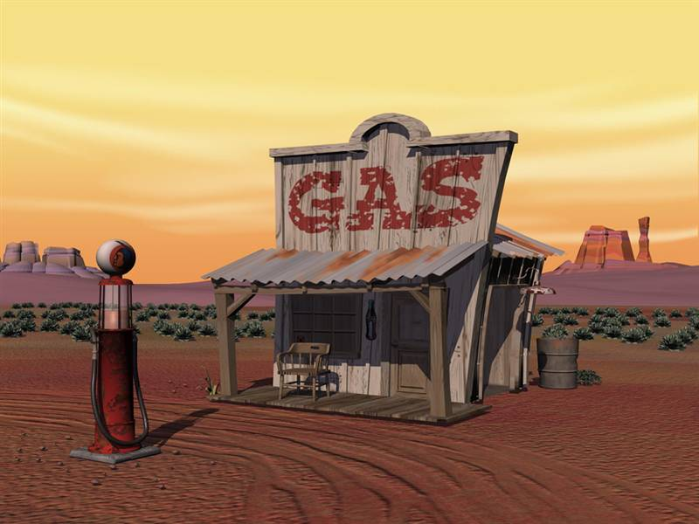
My sketch and plan 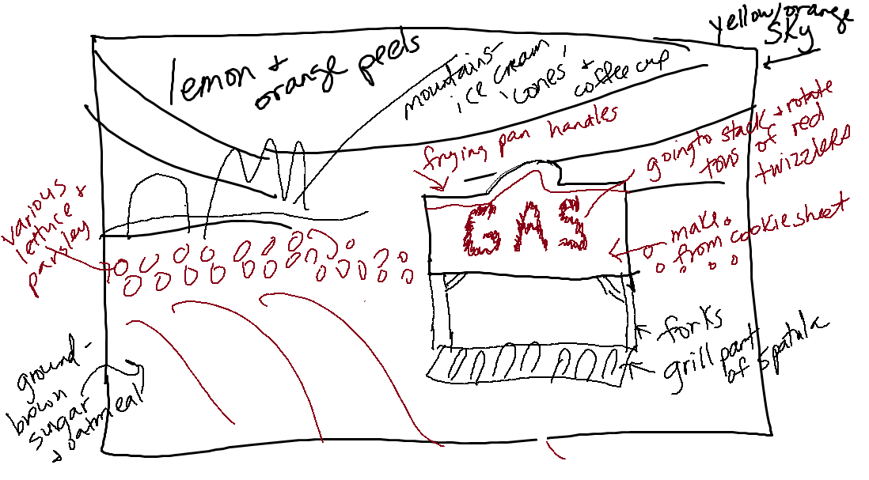
(not finished)

