2. After your buddy and you have labeled the items. Then, you need headphones or earbuds and will work through our example videos.
Create a document like this below using TWO YouTube tutorials:
Part 1-- https://www.youtube.com/watch?v=itsqE_Igyko
Part 2-- https://www.youtube.com/watch?v=yuuoZBMp7gY

Example:
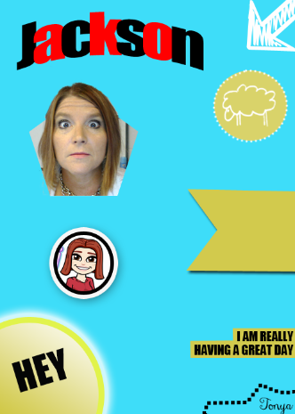
You should have completed BOTH YouTube tutorials and created your own version of this document, showing evidence you can do clipping masks, use layer styles, double strokes, Pen tool, and dotted/dashed path strokes. Be sure yours resembles mine (can be your own colors and pictures, but generally the same). Be sure to Save for Web and upload the JPG version here before you select your magazine cover.

3. Open your Google Drive and create a new Google Document. Start making lists of the following things about yourself: (name it List of Things About Me)
- Your favorite foods---favorite restaurant meal, homecooked food, dessert, candy, beverage, and fast food
- Your favorite shows--favorite movies, favorite TV show, favorite binge watch
- Your favorite social media feeds or apps--YouTube channels, Snapchat/Instagram follows, etc.
- Your favorite music--favorite artists/bands, songs, albums, streaming channels
- Your future plans--school you plan to attend, possible careers, where you hope to live one day
- Your favorite places--cities, amusement parks, or places to hang out
- Your school life--favorite classes, school clubs you belong to, how you're involved (sports, music, etc.)
- Your pet peeves--what bugs you?

4. Find a magazine cover that meets the requirements that you would like to copy. Print the cover in color. Label your selected magazine cover from yesterday with the requirements. If yours does not meet requirements, please throw it away and get a different cover. The only item you may add to the cover is a barcode and be sure to draw where you intend to put it.
5. Once labeled, start a Word document and create a table. Start rewriting your article titles/teasers so they will be about YOU. In the first column, just start listing all the text from the original. In the second column, put what you will change it to. Leave the third column for picking the correct font (not part of today's assignment, though). If you finish rewriting them all, you can start looking for fonts using the ones on your computer using Wordmark.it or searching for those that aren't already loaded using http://dafont.com or other free font sites.
6. Work on your project. Remember to watch closely for layer styles, font sizes, italics, etc. Take your time and don't rush through. Make it look as professional as possible
7. Print a draft copy to the color printer.Compare your printout with your cover. How's it looking? Keep working, paying close attention to font sizes and styles (italics, all-caps, etc.) and layer styles (stroke, drop shadow, glow, etc.). By the end of class today, you should have a PEER REVIEW filled out by someone. Don't lose it; that's on the back of the scoring guide (if you didn't pick one up, pick one up by the flag) and you will turn in the scoring guide

