Basic Photoshop Concepts
These concepts are mostly things that “an average Joe” might want to be able to do quickly in Photoshop.

Resize an Image
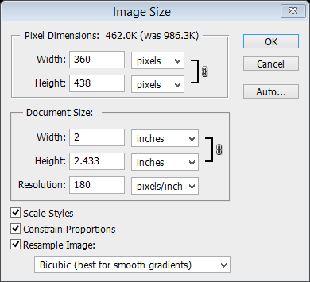
Many times, an image is too big. You DO NOT want to resize something and make it bigger. That rarely works out well.
- First, make sure the Zoom is at 100%. That shows the “actual size” of the image.
- Next, click Image> Image Size.
- You can adjust either at the top set of number (in pixels, which are typically web measurements) or the middle, which is the document size, in inches. Be sure the “chains” are connected to both boxes so you cannot accidentally smash your image.
- Press OK. That’s it!

Save in PSD (and why)
The native format for Photoshop is PSD format. This is a format that will keep things as “editable” as possible. So, if you have multiple layers in a file, you will want to be certain to have a copy in PSD format. If you have more than one layer, it should automatically default to that.
- File> Save As.
- Choose Photoshop PSD on the drop down menu:
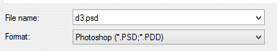
Note that this format pretty much only works in Photoshop. If you wanted to put it on a PowerPoint slide, a website or upload it to some place online to have prints made, they generally won’t accept PSD format. In that case you want a friendlier format. JPG is the most common format used since it can save “16 million colors” and works great for photos:
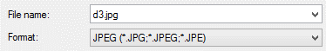
But, if you save in this format and you had layers or words, your layers would all be glued together. You can’t edit the words anymore, you cannot move pieces around anymore, etc. So, be VERY careful!!! This is called “flattening” a file.
Before saving as JPG 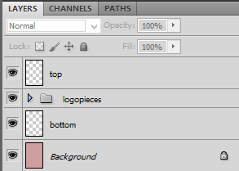 After (flattened) 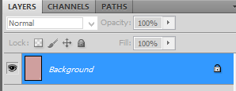

Save for the Web
Ever received an email with an image and it’s HUGE-mongous? Well, they needed to save it to a more appropriate size for the web. And, maybe you want to keep the big original and don’t want to resize it. Here is a simple way:
- Click File> Save for Web and Devices.
- Be sure the top right is set to JPEG format (that’s friendliest for web) and pick a quality (75 is usually fine).
- Set the image size at the bottom (or I usually just grab the Percent and drag until I find the size I want). You can also click the “4 up” tab to see the original and some comparisons (various quality levels and how big they are and how fast they load). Notice in this example, my original was 377 KB in size and the web version at 18% and 75 quality is only 38 KB in size. Big difference! A general rule is to try to get good quality and under 100 KB.
- Click the one you want and press Save. **Use this method to save to your Portfolio folder for all projects.

Quick Border
There are tons of ways to add a border to a picture. A simple way to do this is to make the “canvas” (the space of the image) bigger and fill the bigger area with a color. Here’s the steps:
- Select the top layer in the Layers palette.
- Next click on Image>Canvas Size. In the dialogue box that opens up, change the Width and Height to both to .2 BIGGER(or another number depending on how big you want it to be).
- Choose a color for your border.
- Make sure the center of the Anchor box is selected.
- Click OK and you should see a border around the image.
NOTE: If you wanted, you could actually make a new, blank layer first. Then, it won’t be glued to the picture.

More Space
Similar to adding a border, what if you just needed more space around a picture? For instance, say I wanted to put a hat on a head, but there is no space above it?
- Select the top layer in the Layers palette.
- Next click on Image>Canvas Size. In the dialogue box that opens up, change the Height to a bigger number.
- Make sure the bottom center of the Anchor box is selected. That will make the original image “stick” to the bottom.
- Click OK and you should have some headroom now.
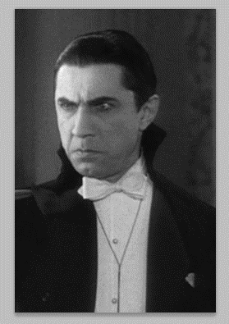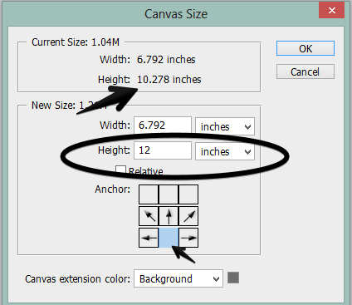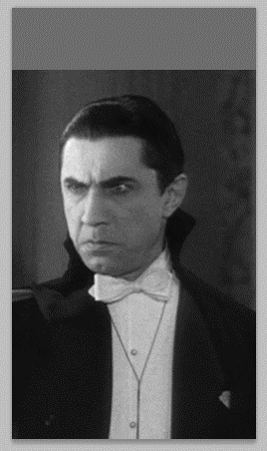

Automatic Photo Fixing
There are three automatic image adjustments you can make in Photoshop CS5—Auto Tone, Auto Contrast, and Auto Color. If you have a picture that looks a little off, try one of those adjustments.
- Click Image> Auto ____________ (whichever one you want to try)
- 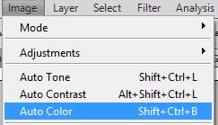 If you don’t like it, you can always undo (Edit> Step Backward)

Remove Color (Monochrome)
Have a color photo and want it to be in black and white? There are a few different image adjustments you can make. The easiest way, is simply to use this:
- Click Image> Adjustments> Black and White.
- It will preview and a box will pop up where you can adjust how dark or light certain colors turn. Play with the sliders a bit until you have it like you like. Or, you can just press Auto.
- Click OK.

Tint an Image
Tint a Photo a Certain Color
- Click Image> Adjustments> Black and White.
- In the Black and White dialog box, check mark the Tint box.
- Adjust the Hue (that is the actual color) or Saturation (that’s how strong the color is) to your liking.
- Click OK.

Crop an Image
- Find the Crop button on the Toolbar--
- Click the button. Click and drag a rectangular region around the area you wish to keep; notice that a Rule of Thirds grid appears to help you line up the photo. After you let go, it will look something like this, but you can still grab any of the little squares and change the size:
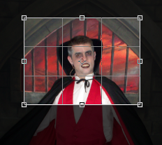
- Press OK or the checkmark on the options bar to accept the change.
NOTE: To crop to a certain size (say you were going to upload it and needed it to be 8 x 10” to print it at Wal-mart or something), in the Options bar at the top, type in the size before you draw the crop box.
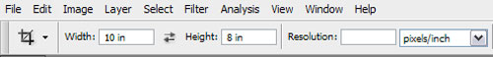

Sharpen a Photo
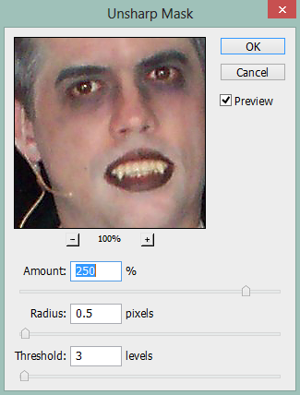
Sometimes, a digital photo might not be totally crisp and clear. You can sharpen this up using what’s called the Unsharp Mask filter. It’s quick and easy. The Unsharp Mask filter makes your image look more focused by adjusting the contrast of the edge detail. Basically, your image looks more focused without actually sharpening the image.
- Click Filter> Sharpen> Unsharp Mask.
- A pop-up will preview the image for you with and without the Unsharp Mask settings. Play with the Amount slider to sharpen as you see fit, then use the Radius slider to determine how many pixels will be effected.
- Click OK to complete.

Straighten a Photo
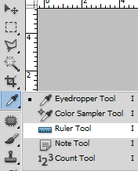
Ever had a picture that wasn’t straight on the horizon? Simple fix.
- Locate the Ruler tool. It typically hides under the Eyedropper tool. Click to select it.
- Draw a line along where the horizon is off; this is the area that you want to straighten out.
- On the Options bar at the top, click Straighten.
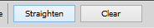
Note that it will cut off any part of your image after it straightens that falls outside the original image area.

Rotate or Mirror (Flip) an Image
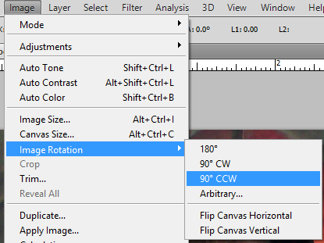
To rotate, choose a measurement. To mirror, select Flip Canvas Horizontal.

Add Type
The standard Horizontal Type tool can be pressed and held down to reveal Vertical Type if you need words going down.
The toolbar looks like this:
Select the font, font style (bold, italic, if available), size, alignment, and color from the Options bar.
Photoshop type is stored in vector form in Photoshop, and as such is fully editable and scalable. Paragraph text is created by clicking and dragging to create a paragraph box, into which you can add lines of wraparound text (where the text wraps within the text box). Or, you can click in the image window and begin typing (this will add a single line of text).

Zoom/Move Around an Image
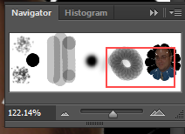
The keyboard shortcuts to zoom in and out are Control and + or Control and – (or you can hold Alt and scroll the mouse wheel). You can also move around an image using the Hand tool, which is quickly access if you hold Spacebar.
Many people just like to use the Navigator window (Window> Navigator) as it has zoom slider buttons (the little mountains at the bottom) and allows you to reposition a red box on the Navigator to get to where you need to be on a large document.

Arrange Open Documents
If you have multiple images open in Photoshop, it typically puts them in tabs. You can’t look at them all at the same time in tabs. Go to Window> Arrange and there are many ways to display open windows.
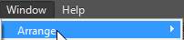

Move Tool
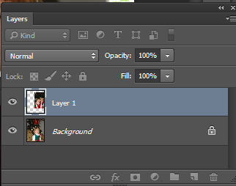
When you have open documents viewable, you can combine images between them by using the Move tool . When you drag and drop into another document, a little “plus sign” appears and then the new addition will be on its own layer in the original image. You can press Control+T to get Transform handles to resize or rotate the new layer (press checkmark or Enter to finalize transformation). Press Shift when resizing to avoid “smashing or stretching” and drag from a corner.
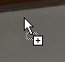 Double-click the Layer # to rename the layer.

