Avatar Yourself—Photoshop Project Name:____________________ Hour:___
Using numerous blending/recolor/retouch techniques including hue/saturation adjustment layers, new layers with blending modes, opacity, liquefy filter (bloat/pucker) and special loaded brushes, you are to create an Avatar version of yourself!
My take on Avatar—before/after and comparison ideas….
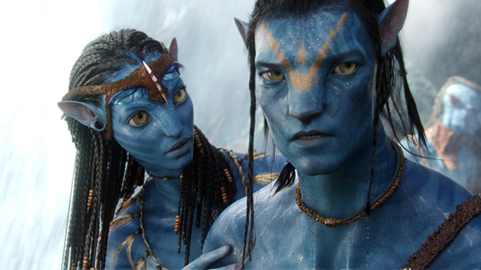
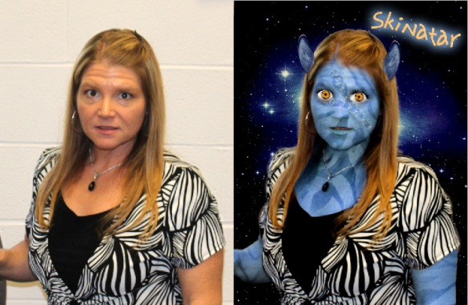
Requirement | Notes | Points Possible
Photo of self is of no more than waist up (we must be able to see the details of the face well!) and high quality! Use flash! | NOTE: Regarding photo size, when beginning, just print/preview and make sure your starting image is not more than 10 inches tall; resize if it is. | 5
Liquefy filter is used to widen nose and increase size of eyes | Use carefully! Make sure it doesn’t look too overdone!
Skin is hue/saturated to be a shade of blue—this includes neck, arms, etc. TOUCH UP! | Use Hue/Saturation adjustment layer; use mask and soft brush to touch up edges, especially around hair line and clothes | 10
A texture is added for artistic effect (consider modifying blend mode and/or opacity) | I used a zebra pattern, warped to fit and masked out the unneeded areas; blend mode was set to soft light (experiment)  BLEND MODE USED: ________________ | 10
Individual removed from background and a dark appropriate background is used instead | I used a galaxy background | 5
Some additional feature is added, recolored to match, and blends well | I used donkey ears and used a Color Balance to make them blue and clone stamped some hair on a layer above it to blend | 5
Special loaded brush is used for embellishment (sparkles to face or other artwork added to subject)—ON NEW LAYER | I used sparkle brushes for the face and eyelash brush for the eyes; I stamped it on and selected it with the rectangle and warped it around the eye socket; I added glow layer style to the sparkles  BRUSH(ES) USED:_________________ | 10
Eyes are changed to a colorful color either by painting, cloning from another image, or moved over from another picture | I found some eyes online and changed the color a little bit with adjustment layer; I punched out/painted out my eye sockets first. | 5
Overall quality | Quality of blending, etc., and printed in color | 5
TOTAL |  | 60
Upload BEFORE and AFTER photo to Portfolio;
See reverse for some tips for success!
Suggestions:

- THINK about your “before” photo; girls, think about pulling your hair back to make it easier (or at least out of your face

- Use Hue/Saturation adjustment layer to recolor your skin; modify saturation if it’s “too blue” so that it can blend well, especially around hair

- Consider using the healing brush to remove the edges (left/right) of your nose to give a flatter look

- You may choose to clone/copy eyes from another source for this as long as you use your own eye sockets (just punch out/mask out holes).

- To make something that is grayscale a color, try a Color Balance adjustment layer (instead of hue/sat)

- Some brushes that are helpful on the Z drive-- eyelash brushes (SS-eyelashes)

- Consider overlaying a zebra pattern (consider soft light or other blending mode on the Layers pull down) to create your stripes or another

- Make a layer with some soft little dots for the glowy dots...or use SS-glitter brushes and add an Outer Glow layer style

